Android
Android is an open source and Linux-based Operating System for mobile devices such as smartphones and tablet computers
Architecture

Applicatons--contains home, contacts, browser,
Application Framework--contains ,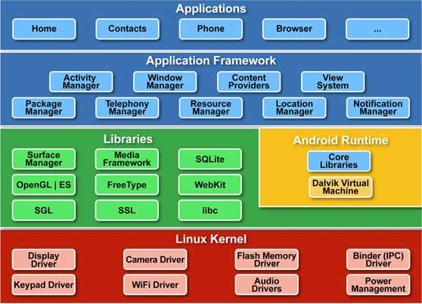 content providers, window manager,resource manager, activity manager..
Libraries---contains API
Linex Kernel--contains drivers
In Libraries Android Runtime contains core libraries and Dalvik Virtual Machine
Components
Component is simple piece of code that has a well defined life cycle
The fundemental components of Android are
Activity
Services
View
Intent
content providers
Android Manifest.xml
Activity is a class that represents a single screen.
Service is background process that can run for a long time
These services are accessed within the applications or from other applications running in the same device.
Views is the UI(User Interface) element such as button,text field..etc
Intents are used for invoking components
start the service
launch an activity
dislay a webpage
Content Providers are used to share data from one application to another application.The data can be stores in files or databases.
Android Manifest.xml contain information about activities, content providers, permissions etc(like web.xml in javaEE)
Fragments--Represents a behavior or a portion of user interface in an Activity.
Layouts--View hierarchies that control screen format and appearance of the views.
Resources--External elements, such as strings, constants and drawables pictures.

Structure of a Android Application
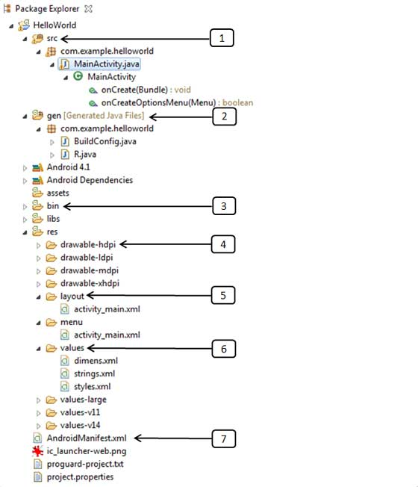
src contains .java source files.
By default MainActivity.java is there.
Execution starts from this file.
If number of activity clases are there then select one among those and taken initiatives.
gen contains .R file, a compiler generated file.
It references all the resources found in our project.
contains ID's for all the resources
You shouldnt modify this file.
bin contains android packaging files like .apk
these are build by the ADT during the build proces.
AAPT is Android Asset PackagingTool.
It handles the packaging process.
it is created by framework automatically.
If we want to run the android application on the mobile, transfer and install it.
Resources
res/drawable
res/layout
res/values
drawable:stores images(.png)

Layouts
Linear Layout: aligns all children in a single direction either horizontally or vertically.
Relative Layout: displays child views in relative positions
Grid Layout:displays in 2Dimensional way.
Table Layout: displays in rows and columns.
Frame Layout:display in a single view
List Layout: display a list of scrollables
Absolute Layout : displays exact positions using (x,y) co-ordinates.
Some of attributes are
Android: id(uniquely identifies the view.),
Android:layout_width,
Android:layout_height
FrameLayout is designed to block out an area on the screen to display a single item. You can add multiple children to a FrameLayout and control their position within the FrameLayout using gravity. Children are drawn in a stack, with the most recently added child on top. The size of the frame layout is the size of its largest child (plus padding), visible or not (if the FrameLayout's parent permits). Views that are GONE are used for sizing only if setConsiderGoneChildrenWhenMeasuring() is set to true.
Values
dimens.xml
strings.xml
styles.xml

dimensions or members(variables) or styles defined in these xml files can be retreived in our java file
we can retrieve these values in these xml files from anywhere and any number of times in this application(java files)
Android Manifest.xml contain information about activities, content providers, permissions etc(like web.xml in javaEE)
It describes the fundemental characteristics of the application and defines each of its components.
Whatever component you develop as a part of your application,you must declare all its components in AndroidManifest.xml file.
if you do not declare your component in this file, then it will not be considered by the OS
Fragment
Fragment is a small chunk of UI
it has its own life cycle
it can be added or removed when activity is running
Android Emulator
Android Emulator is used to run, debug and test the andoid applications.
If you don't have a real device it is best to run, debug and test the android applications.
UI Controls
TextView: used to print text
For Example:
TextView textview=(TextView) findViewById(R.id.text_id);
Final String Laber=textview.getText().toString();
EditText: used to edit text.that means we can enter modify values at runtime.
AutocompleteTextView: It is similar to EditText.
when we typing it suggest some text automatically.
Button
ImageButton: It is same as button but here is image instead of text.
CheckBox:used to select multiple options
RadioButton:used to select only option among multiple options
Spinner: It contains a dropdown list and have to select one among all values.
ProgressBar: It shows the status of how much completed so far.
TimePicker: used to select the time.
It has two modes.24hours and 12 hours(AM and PM)
DatePicker:used to select date.`
Android Screen Orientation
unspecified: it is the default case.
potrait: taller
landscape: wider
sensor: orientation is determined by the device orientation sensor

Toast
Toast class is used to show notification for a interval of time.
After sometime it willl disappear.
It doesnt block the user interaction

Event Handling
Events are a useful way to collect data about a user's interaction with interactive components of your app, like button presses or screen touch etc.
The Android framework maintains an event queue into which events are placed and is removed from the queue on a first-in, first-out (FIFO) basis.
Event Listeners: The View class is mainly involved in building up a Android GUI, same View class provides a number of Event Listeners. The Event Listener is the object that receives notification when an event happes.
Event Listeners Registration: Event Registration is the process by which an Event Handler gets registered with an Event Listener so that the handler is called when the Event Listener fires the event.
Event Handlers: When an event happens and we have registered and event listener fo the event, the event listener calls the Event Handlers, which is the method that actually handles the event.
Event Listener and Event Handlers
OnClick-------OnClickListener()
This is called when the user either clicks or touches or focuses upon any widget like button, text, image etc. You will use onClick() event handler to handle such event.
OnLongClick----OnLongClickListener()
This is called when the user either clicks or touches or focuses upon any widget like button, text, image etc. for one or more seconds. You will use onLongClick() event handler to handle such event.
OnFocusChange--------OnFocusChangeListener()
This is called when the widget looses its focus ie. user goes away from the view item. You will use onFocusChange() event handler to handle such event.
onKey----OnFocusChangeListener()
This is called when the user is focused on the item and presses or releases a hardware key on the device. You will use onKey() event handler to handle such event.
OnTouch-------OnTouchListener()
This is called when the user presses the key, releases the key, or any movement gesture on the screen. You will use onTouch() event handler to handle such event.
OnMenuItemClick------OnMenuItemClickListener()
This is called when the user selects a menu item. You will use onMenuItemClick() event handler to handle such event.
Event Listeners Registration:
Event Registration is the process by which an Event Handler gets registered with an Event Listener so that the handler is called when the Event Listener fires the event. Though there are several tricky ways to register your event listener for any event, but I'm going to list down only top 3 ways, out of which you can use any of them based on the situation.
1.Using an Anonymous Inner Class
2.Activity class implements the Listener interface.
3.Using Layout file activity_main.xml to specify event handler directly.
Examples related to these event handling.

Activity in detail
Activity is a class that represents a single screen.
Android program takes initiation with the activity(on create()) like main class in java.
Application contains any number of activities.Among those select one activity as initiative.
Reuse the same activity across several activities.
an activity class loads all UI components using the XML file available in res/layout folder of the project.
setContentView(R.layout.activity_main);
loading UI components from res/layout/activity_main.xml.
There are 7 life-cycle methods of activity. They are
onCreate()
onStart()
OnResume()
onPause()
onStop()
onRestart()
onDestroy()
SQLite: An opensource and lightweight relational database for mobile devices.
Services in details
A service is a component that runs in the background to perform long-running operations without needing to interact with the user.
For example, a service might play music in the background while the user is in a different application, or it might fetch data over the network without blocking user interaction with an activity.
A service can essentially take two states:
started
bound
Started
A service is started when an application component, such as an activity, starts it by calling startService(). Once started, a service can run in the background indefinitely, even if the component that started it is destroyed.
Bound
A service is bound when an application component binds to it by calling bindService(). A bound service offers a client-server interface that allows components to interact with the service, send requests, get results, and even do so across processes with interprocess communication (IPC).
Callback methods and description
A service has lifecycle callback methods that you can implement to monitor changes in the service's state and you can perform work at the appropriate stage.

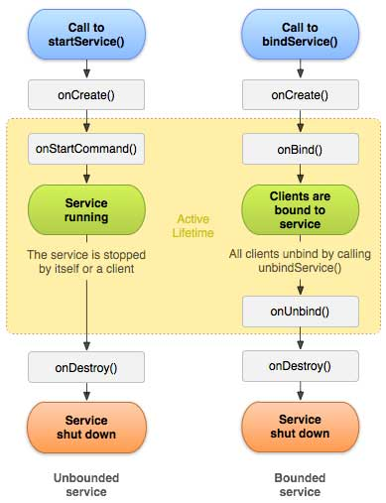
onStartCommand()
The system calls this method when another component, such as an activity, requests that the service be started, by calling startService(). If you implement this method, it is your responsibility to stop the service when its work is done, by calling stopSelf() or stopService() methods.
onBind()
The system calls this method when another component wants to bind with the service by calling bindService(). If you implement this method, you must provide an interface that clients use to communicate with the service, by returning an IBinder object. You must always implement this method, but if you don't want to allow binding, then you should return null.
onUnbind()
The system calls this method when all clients have disconnected from a particular interface published by the service.
onRebind()
The system calls this method when new clients have connected to the service, after it had previously been notified that all had disconnected in its onUnbind(Intent).
onCreate()
The system calls this method when the service is first created using onStartCommand() or onBind(). This call is required to perform one-time setup.
onDestroy()
The system calls this method when the service is no longer used and is being destroyed.
Your service should implement this to clean up any resources such as threads, registered listeners, receivers, etc
Fragments in detail
Fragment
Fragment is a small chunk of UI
it has its own life cycle
it can be added or removed when activity is running
Reuse the same activity across several activities.
A fragment has its own layout and its own behavior with its own lifecycle callbacks.
You can add or remove fragments in an activity while the activity is running.
You can combine multiple fragments in a single activity to build a multi-pane UI.
A fragment can be used in multiple activities.
Fragment life cycle is closely related to the lifecycle of its host activity which means when the activity is paused, all the fragments available in the acivity will also be stopped.
A fragment can implement a behavior that has no user interface component.
You create fragments by extending Fragment class and You can insert a fragment into your activity layout by declaring the fragment in the activity's layout file, as a <fragment> element.
Prior to fragment introduction, we had a limitation because we can show only a single activity on the screen at one given point in time. So we were not able to divide device screen and control different parts separately. But with the introduction of fragment we got more flexibility and removed the limitation of having a single activity on the screen at a time. Now we can have a single acitivity but each acitivity can comprise of multiple fragments which will have their own layout, events and complete lifecycle.
Following is a typical example of how two UI modules defined by fragments can be combined into one activity for a tablet design, but separated for a handset design.
Fragment Life Cycle
Android fragments have their own life cycle very similar to an android activity. This section briefs different stages of its life cycle.
Phase I: When a fragment gets created, it goes through the following states:
onAttach()
onCreate()
onCreateView()
onActivityCreated()
Phase II: When the fragment becomes visible, it goes through these states:
onStart()
onResume()
Phase III: When the fragment goes into the background mode, it goes through these states:
onPaused()
onStop()
Phase IV: When the fragment is destroyed, it goes through the following states:
onPaused()
onStop()
onDestroyView()
onDestroy()
onDetach()
BroadCast Receivers in details
There are following two important steps to make BroadcastReceiver works for the system broadcasted intents:
Creating the Broadcast Receiver.
Registering Broadcast Receiver
Creating the Broadcast Receiver
A broadcast receiver is implements BroadcastReceiver class.
In this class we overriding the onReceive() method where each message is received as a Intent object parameter.
public class MyReceiver extends BroadcastReceiver
{
@Override
public void onReceive(Context context, Intent intent)
{
Toast.makeText(context,"IntentDetected.",toaast.LENGTH_LONG).show();
}
}
Registering Broadcast Receiver
An application listens for specific broadcast intents by registering a broadcast receiver in AndroidManifest.xml file.
Consider we are going to register MyReceiver for system generated event ACTION_BOOT_COMPLETED which is fired by the system once the Android system has completed the boot process.
<application
android:icon="@drawable/ic_launcher"
android:label="@string/app_name"
android:theme="@style/AppTheme" >
<receiver android:name="MyReceiver">
<intent-filter>
<action android:name="android.intent.action.BOOT_COMPLETED">
</action>
</intent-filter>
</receiver>
</application>
Events
android.intent.action.BATTERY_CHANGED states charging state,level and other infomation about battery.
BATTERY_LOW Indicates low battery condition on the device.
BATTERY_OKAY Indicates the battery is now okay after being low.
BOOT_COMPLETED This is broadcast once, after the system has finished booting.
BUG_REPORT Show activity for reporting a bug.
CALL Perform a call to someone specified by the data.
CALL_BUTTON DATE_CHANGED The date has changed.
REBOOT device rebooted
Broadcasting Custom Intents
If you want your application itself should generate and send custom intents then you will have to create and send those intents by using the sendBroadcast() method inside your activity class.
public void broadcastIntent(View view)
{
Intent intent = new Intent();
intent.setAction("com.tutorialspoint.CUSTOM_INTENT");
sendBroadcast(intent);
}
This intent com.tutorialspoint.CUSTOM_INTENT can also be regsitered in similar way as we have regsitered system generated intent.
<application
android:icon="@drawable/ic_launcher"
android:label="@string/app_name"
android:theme="@style/AppTheme" >
<receiver android:name="MyReceiver">
<intent-filter>
<action android:name="com.tutorialspoint.CUSTOM_INTENT">
</action>
</intent-filter>
</receiver>
</application>
Content Providers in detail
A content provider component supplies data from one application to others on request. Such requests are handled by the methods of the ContentResolver class.
A content provider can use different ways to store its data and the data can be stored in a database, in files, or even over a network.
Each Android applications runs in its own process with its own permissions which keeps an application data hidden from another application. But sometimes it is required to share data across applications. This is where content providers become very useful.
A content provider behaves very much like a database where you can query it, edit its content, as well as add or delete content usingg insert(), update(), delete(), and query() methods. In most cases this data is stored in an SQlite database.
A content provider is implemented as a subclass of ContentProvider class and must implement a standard set of APIs that enable other applications to perform transactions.
Public class MyContentProvider extends contentProvider
{
}
Content URIs
To query a content provider, you specify the query string in the form of a URI which has following format:
<prefix>://<authority>/<data_type>/<id>
content://contacts/people/5.
Here is the detail of various parts of the URI:
<prefix>This is always set to content://
<authority> specifies the name of the content provider
for example contacts, browser etc.
For third-party content providers, this could be the fully qualified name, such as com.tutorialspoint.statusprovider
<data_type> indicates the type of data that this particular provider provides.
For example, if you are getting all the contacts from the Contacts content provider, then the data path would be people and URI would look like this content://contacts/people
<id> specifies the specific record requested.
For example, if you are looking for contact number 5 in the Contacts content provider then URI would look like this content://contacts/people/5.
Create Content Provider using ContentProvider class
Register Content Provider using <provider>tag
Create Content Provider
This involves number of simple steps to create your own content provider.
First of all you need to create a Content Provider class that extends the ContentProviderbase class.
Second, you need to define your content provider URI address which will be used to access the content.
Next you will need to create your own database to keep the content. Usually, Android uses SQLite database and framework needs to override onCreate() method which will use SQLite Open Helper method to create or open the provider's databse. When your application is launched, the onCreate() handler of each of its Content Providers is called on the main application thread.
Next you will have to implement Content Provider queries to perform different database specific operations.
Finally register your Content Provider in your acitivity file using <provider> tag.
Here is the list of methods which you need to override in Content Provider class to have your Content Provider working:
onCreate() This method is called when the provider is started.
query() This method receives a request from a client. The result is returned as a Cursor object.
insert()This method inserts a new record into the content provider.
delete() This method deletes an existing record from the content provider.
update() This method updates an existing record from the content provider.
getType() This method returns the MIME type of the data at the given URI.
Android Intents
An Android Intent is an object carrying an intent ie. message from one component to another component with-in the application or outside the application. The intents can communicate messages among any of the three core components of an application - activities, services, and broadcast receivers.\
The intent itself, an Intent object, is an description of an operation to be performed.
There are separate mechanisms for delivering intents to each type of component - activities, services, and broadcast receivers.
There are two types of intents.They are
Explicit intents
implicit intents
Explicit Intents
Explicit intents help us to move from one Activity to another Activity.
We know to whom we are sending i.e Activity B..
It can done by two ways.
Intent i=new Intent(Activity A.this, Activity B.class);
startActivity(i);
(OR)
Intent i=new Intent()
I.setClassName(“packagename”,”packagename.Activity B”);
startActivity(i);
Implicit Intent
We dont know to whom we are sending
For example we are sending an Email. We dont to what activity we are sending.
When we using Implicit Intent we use concept of Implicit Filters.
The component you call doesnt need to be running.
Android PackageManager is responsible for deciding which component is suited to handle your event.
Implicit Intent contains
Action
Define what you want to do
Ex: place a phone call
Data
What type of data do u want to work with
Ex: uri, images
Extras
What additional information you need to provide(key/value pairs)
Ex: phone number of a person to call
Catogories
Create group of components to handle the intent
Ex: place a Activity A in the launcher.
Intent Filter is like a Advitisor which sends details of action data catory to particular Activity or Broadcast Reciever or service after checking if it is ok.(exist or matches)
<acttion><data><catagory>
If doesnt exist then No apps can perform this action
If more than one exist that can handle the intent--complete action using(select one of the multiple options having.)

